GERM 880: Man, Animal, Cinema
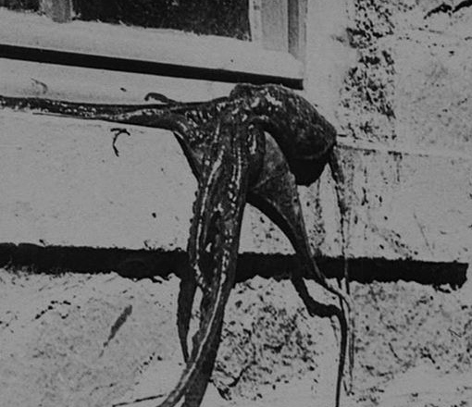
Spring 2014
Prof. Inga Pollmann
Tu 4:40-7:10pm
Dey Hall 404
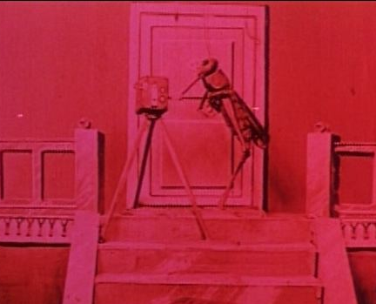
This course proposes a cinematic investigation into—and intervention in—the historical and current debate about the ontological, political, biological, and emotional relationships between human beings and animals. To familiarize ourselves with this fundamental debate, we will read not only key philosophical texts, but also literary and scientific texts that approach this problem from the perspective of their own media and disciplines. However, the central goal of this course will be to consider the role of technology and mediation—and of the cinema in particular—for the “question” of the animal. To this end, we will confront philosophy and science with a variety of films as well as engage film criticism that focuses on the ways in which film communicates, mediates, and transforms creaturely life. What happens to animals when they are technologically mediated, what happens to technology in conjunction with the animalistic, and what happens to (human) spectators in the film experience of wild, anthropomorphous, strange, or horrifying creatures?

In addition to key texts of the current debate (Giorgio Agamben, Jacques Derrida, Cary Wolfe, and others) and classic positions, we will also look at the long history of the man/animal question, beginning with Aristotle but focusing on debates that took place primarily in Germany (and to a lesser extent in France) in the early 20th century, involving authors such as Jakob von Uexküll, Martin Heidegger, Georges Canguilhem, Wolfgang Köhler, and Max Scheler. This canon is supplemented by literary texts by Rainer Maria Rilke, Franz Kafka, and J. M. Coetzee. The films cover a broad range of genres, styles, and periods, and encompass early safari and hunting films, popular science films, animation, documentaries, narrative films featuring animals, and contemporary experimental film and video, including films by Werner Herzog, Robert Bresson, Carolee Schneemann, Stan Brakhage, Jean Painlevé, and F. W. Murnau.
This course requires occasional film viewings outside of class and also counts toward the Graduate Certificate in Philosophy, Arts and Literature (PAL) at Duke.

